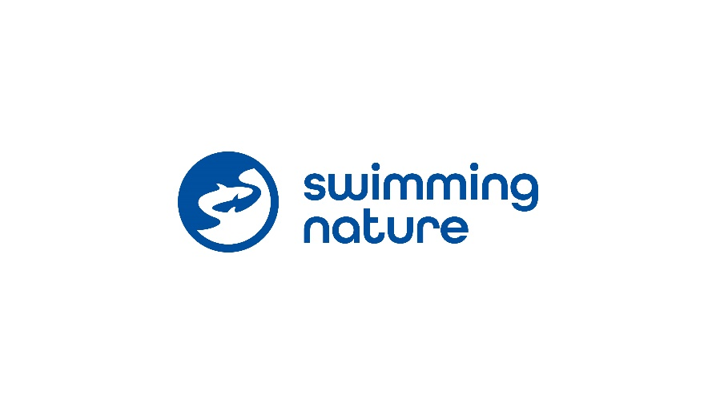
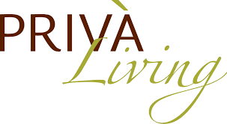

PRIVA Living, Arjan, Dubai
Swimming Nature UAE Partnership Proposal

Swimming Nature has been delivering private swimming lessons in the UK for over 33 years, has won awards for its teaching methodology and their students average 5-6 years ahead of the British curriculum. Founder owned, the company is now expanding to the UAE and seeking quality partnerships to enable students to swim beautifully!

Supported by the teams across the UAE and the UK, Swimming Nature has built strong partner support with a highly trained customer support centre, seamless online booking systems, experienced marketing support and a detailed analytics system to enable partners maximise their swimming provision.

- Partnership Services:
When relating to swimming lessons, Swimming Nature will be completely in charge of the weekday operation, including sales, marketing and customer services. Swimming Nature teachers will set up the pool space allocated and handle poolside communications with customers. Payment of wages to teachers and lesson payment from customers is managed by Swimming Nature. The scheduling will be agreed between Swimming Nature and Priva living and the booking function will be managed through the Swimming Nature software.
  - Swimming Nature to adhere to venue safety guidelines, ensure customers also do so, and only operate when a lifeguard is present.
  - Swimming Nature to ascertain, implement and adhere to all requirements requested by Priva Living to minimise resident disruption. Including but not limited to:
    - Teachers responsible for communication of pool side ‘etiquette’ to new and existing customers.
    - Dedicated management contact to support operations and service issues – with quarterly meetings to support partnership and performance.
  - Swimming Nature to provide online booking services to ensure smooth customer journey.
  - Automated renewals for swimming lessons ensuring hassle-free re-enrolment.
  - Access to Swimming Nature’s online portal which provides all information to Priva Living around instructor compliance, student numbers, timetables, term dates and demographics

- Marketing and Cross marketing Opportunities
- Swimming Nature to invest in dedicated social media campaigns for generating new customer leads which can be used to market Priva Living stays and facilities.
- 10% discount to be offered to all current Priva Living residents
- Cross marketing opportunities where Priva Living can promote their offering to Swimming Nature customers and where Swimming Nature can promote their offering to Priva Living residents, and potential new residents/stays.

- Teachers:
All Swimming Nature teachers hold the required teaching and safety qualifications, as outlined by the governing bodies, as well as an up-to-date Dubai Police check. In addition to the above, all Swimming Nature teachers must complete bespoke courses and upskills in order to follow the unique and successful methodology.
- Payment Model:
Swimming Nature agrees to pay Priva Living 60aed per half an hour lesson. Trial method for the first two terms. Opportunity to look at basic rent/revenue share model from term three based on performance of partnership.
- Bookings:
All bookings and Customer Service matters will be handled exclusively by Swimming Nature through both a dedicated in-house team, and through Swimming Nature’s website where customers can find venue specific information and enrol their lessons. Enquiries made at reception can be passed to our Swimming Nature team.
- Pool Times:
Children’s Swimming Lessons
Monday to Thursday: 4pm to 9pm
Friday: 2pm to 9pm
Saturday to Sunday: 8am to 11am

Adult Lessons
Individual (agreed by Swimming Nature and Priva Living in advance)

NOTES:
- Children lessons based on a 1:1 or a 2:1 per instructor
- The times above to be made available for the standard weeks of the year. Eid/Easter, Summer and Christmas periods to be discussed.
- Allocated space to operate within – each lane 1m wide

- Payment:
Payment made monthly via bank transfer to a specified bank account on a date agreed by both parties

- Exclusivity:
Swimming Nature to be the sole provider of swimming lessons at the Priva Living, Arjan pool.

- Start date:
  - Promotional Start Date – 1st October 2024. Term one to build clientele.
  - Operational starting date – 4th January 2025. Term two.

- Facilities:
Swimming Nature to have a space for instructors to change and store their equipment and personal belongings.

- Insurance:
Swimming Nature will provide a copy of public and employer liability insurance.

- Confidentiality:
This document and all related communication is to be considered confidential and not to be shared with any other party without our written consent.

